MUHAMMED JASIR.P

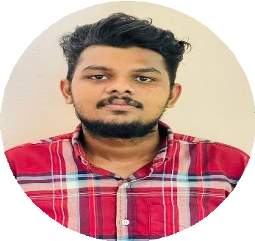

PYTHON Full Stack Developer

Phone: +919995458196 Email: [jazjasir7@gmail.com](mailto:jazjasir7@gmail.com)

# PROFILE

Information Technology Professional holding a Bachelor Degree with computer Application.

My strength lies in my ability to learn new technologies and skills quickly, work in teams and good communication skills. My area of specialization is Web Development /Engineering.

# SUMMARY OF SKILLS

* Strong Knowledge in Django (framework of PYTHON) application development and deployment
* Strong communication skills
* Improved problem-solving skills
* Logical approach to work
* Ability to explain technical matters clearly
* Keen interest in technology
* Working with MySQL ,PostgreSQL Database in Django
* Good knowledge in JavaScript, CSS, Bootstrap,HTML
* More interested work with team
* Basic knowledge in Flask and Django Rset API

# PROJECT

## HURRYFOOD

**Company project**

› HURRYFOOD is a webapp. This project mainly contains dining prebooking system and food delivery.

› Hurryfood created with frontend using JS and backend with PYTHON(Django), database is SQL.

## SAFEWAY

**Academic project**

› SAFEWAY is an ecommerce and Shopping web app. A complete shopping webapp, there will be a many stored hosted in the application .The customer could easily buy products.

› Safeway created with frontend using JS and backend with PYTHON(Django), database is SQL.

# EXPERIENCE – 0.6 Year

**Nov 2022 –**

**Apr 2023**

**SOFTEN TECHNOLOGIES**

**PYTHON full stack Developer**

# CERTIFICATIONS AND TRAINING

* + Participated in internship on “PYTHON Full Stack Development”

Conducted by **Soften Technologies**

# EDUCATION

2019-2022 **BCA(Bachelor oCfomputerApplication)**

Calicut University, Kerala, India

2017-2019 **HigherSecondar(yScience)** St.Paul’s EMHSS Thenhipalam Kerala, India

JUNE 2017 **SSLC**

MHSS Moonniyur, Kerala, India

# PROFILE

- https://[www.linkedin.com/in/jasir123](http://www.linkedin.com/in/jasir123)

# LANGUAGES KNOWN

**English** - Reading, writing & speaking.

**Hindi** - Reading, writing

**Arabic** - Reading, writing

**Malayalam** - Native Language

# PERSONAL INFORMATION

**Nationality :** Indian

**MaritalStatus :** Single

**Availability :** Immediate Joining